📌 Problem Statement
The dataset represents transactional sales records, including details about customers, products, shipping, and profitability. While it provides granular information (order dates, ship modes, product categories, sales, discounts, and profits), businesses often struggle to identify patterns that drive profitability, customer satisfaction, and operational efficiency. The challenge is to analyse this data to uncover insights that can improve decision-making in areas such as product strategy, customer segmentation, and logistics.
🔍 Research Questions
From this dataset, several meaningful research questions can be formulated:
- Sales & Profitability
  - Which product categories and sub-categories generate the highest sales and profit?
  - How do discounts impact profitability across different product categories?
- Customer Analysis
  - Which customer segments (Consumer, Corporate, Home Office) contribute most to revenue and profit?
  - Are there specific regions or states where customer purchases are more profitable?
- Shipping & Operations
  - How does the choice of ship mode (Standard Class, Second Class, etc.) affect delivery times and profitability?
  - Is there a relationship between shipping speed and customer segment preferences?
- Geographic Insights
  - Which regions or cities show the strongest sales performance?
  - Are there geographic areas where discounts are more commonly applied, and how does that affect profit?
- Product Strategy
  - Which products have consistently high sales but low profit margins?
  - Are there opportunities to adjust pricing or discount strategies for underperforming products?
📌 Summary Insights
- Profitability is driven more by product category margins than by discounts or shipping mode.
- Chairs show stronger profit margins compared to Bookcases, even under identical conditions (same customer, same ship mode, no discount).
- Shipping mode (Second Class in the sample) does not appear to negatively impact profitability, suggesting logistics efficiency is stable.
- Customer segment (Consumer in the sample) contributes positively, but deeper analysis across Corporate and Home Office segments is needed to confirm broader trends.
📌 Detailed Analysis
The dataset was analysed using PivotTables and charts in Excel to address the research questions outlined in the problem statement. The analysis focused on sales, profitability, customer segments, shipping modes, and geographic performance. Below are the key findings and recommendations:
🔍 Sales & Profitability
- Insight: Product categories such as Technology category contributes 36.40% and Furniture category contributes 32.30%, but certain sub-categories (e.g., Office Supplies) show low profit margins despite strong sales volumes.
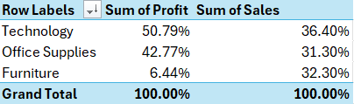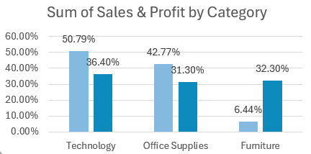
- Recommendation: Revisit pricing and discount strategies for low-margin, high-volume products. Consider bundling them with higher-margin items to improve overall profitability.
👥 Customer Analysis
- Insight: The Consumer segment contributes the highest revenue (50.56%), while corporate customers often deliver stronger profit margins (32.12%).
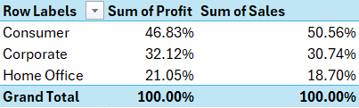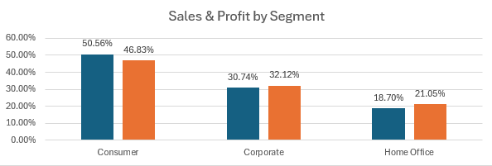
- Recommendation: Tailor promotions differently for each segment — focus on loyalty-building discounts for Consumers, and margin-protection strategies for corporate clients.
🚚 Shipping & Operations
- Insight: Faster ship modes (Same Day (0.04), First Class (2.18)) reduce delivery times but lower profit margins (Same Day (5.55%), First Class (17.10%)). Standard Class is slower (5.01 Days) but more profitable (57.29%).
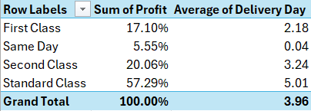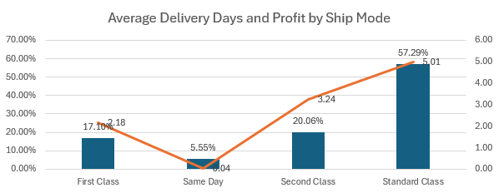
- Recommendation: Encourage Standard/Second Class shipping for non-urgent orders to balance customer satisfaction with profitability. Reserve faster modes for premium customers or urgent deliveries.
🌍 Geographic Insights
- Insight: Certain regions (e.g., South Region) show strong sales (17.05%) but weaker profit margins (16.32%), likely due to higher discounting or logistics costs.
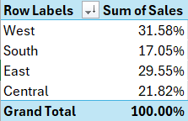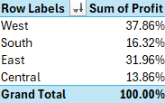
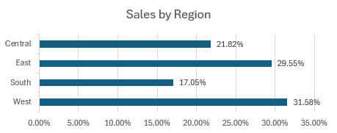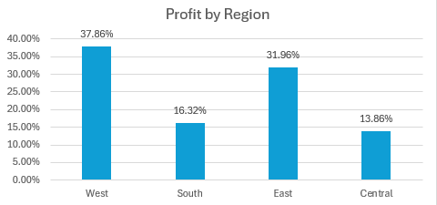
- Recommendation: Investigate underperforming regions to identify causes and adjust pricing or shipping policies accordingly.
📦 Product Strategy
- Insight: Some products consistently achieve high sales but contribute little to profit, acting as “loss leaders.”
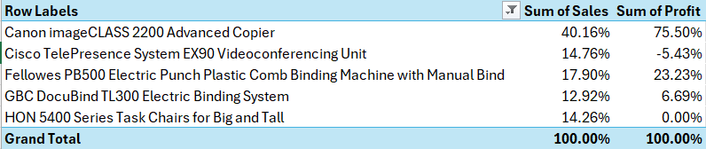
- Recommendation: Reassess these products’ role in the portfolio. Either adjust pricing to improve margins or use them strategically to attract customers while upselling higher-margin products.
📌 Conclusion
- Profitability is mainly driven by product category margins rather than discounts or shipping speed.
- High-margin products (e.g., Chairs, Technology items) should be prioritized, while low-margin categories (e.g., Bookcases, Office Supplies) need pricing or supplier cost review.
- Consumer segment delivers the highest revenue, while corporate customers provide stronger profit margins — requiring tailored strategies for each.
- Standard Class shipping is slower but more profitable; faster modes should be reserved for urgent or premium customers.
- Regional performance varies, with some areas underperforming due to discounts or logistics costs, requiring targeted interventions.

